com

**Institutional Review Board**

**Intervention/Interaction Detailed Protocol**

Principal Investigator: Gayun Chan-Smutko

Project Title: Assessing Autonomy in Healthcare Decision-Making for Adults with

Down Syndrome

Version Date: 11/12/2024

Version Name/Number: V3

*For Intervention/Interaction studies, submit a Detailed Protocol that includes the following sections. If information in a particular section is not applicable, omit and include the other relevant information.*

1. **Background and Significance**

The majority of adults with Down Syndrome under 40 live with their parents rather than independently, in group homes, or other residential circumstances [(Lee et al., 2021)](https://www.zotero.org/google-docs/?nhIpyw). While this may result in a lower financial burden on families, the outcomes for individuals living at home can become intrinsically tied to the family’s access to resources, time and ability to provide care, as well as factors such as the health and age of the caregivers. It is not well understood how the residential circumstances of individuals with disabilities impacts their overall independence and autonomy, but there are likely benefits and drawbacks to every residential environment. Past research has reported a range of outcomes for people in out-of-home care (OOHC), with an increased level of independent living skills being amongst the positive findings [(Crettenden et al., 2014)](https://www.zotero.org/google-docs/?yRQFj6). This may be due to caregivers having the ability to focus on cultivating specific opportunities for building independence in OOHC as they work shifts and have designated days off, where families may struggle to balance being the main or sole providers of care and find it easier to do tasks themselves instead of assisting their family member in learning.

In regards to health care, individuals with Down Syndrome and other disabilities spend more time with doctors than abled individuals, whether that is due to health complications or increased check-ups and referrals to specialties [(Kennedy et al., 2017; van den Driessen Mareeuw et al., 2020a)](https://www.zotero.org/google-docs/?kWXjss). Despite frequent interactions, interviews with adults with Down Syndrome and their caregivers have noted less positive interactions, with an increase in negative interactions in adults over children or adolescents with Down Syndrome [(van den Driessen Mareeuw et al., 2020b)](https://www.zotero.org/google-docs/?1q8tpj). Disabled individuals and their support systems are noted to emphasize the importance of “person-focused care” particularly by including the patient in conversations about their health. Despite this desire, providers and institutions are not encouraged to follow models of person-centered care as standard practice but rather to focus on separate and individual conditions to be treated or cured [(Kinnear et al., 2018; Valentijn et al., 2013)](https://www.zotero.org/google-docs/?0VKc6J).

Along with person-focused care not being a current standard, there is a lack of support for disabled people transitioning between care providers which may result in individuals staying with a provider that is not meeting their needs. Specifically regarding adults with Down Syndrome, the transition from pediatric to adult care is a barrier that results in adults receiving care from a pediatric provider and having worse overall health outcomes such as increased rates of comorbidities and health issues [(Varshney et al., 2022)](https://www.zotero.org/google-docs/?zXaQVl).

There is a large literature gap around the specific perspectives of adults with Down Syndrome on their relationships with health care providers, and their role as independent individuals in their own care. The field that has the most relevant literature is gynecological care of women and AFAB individuals with Down Syndrome. Despite the topic being more well studied, research shows that there is poor engagement of adults with Down Syndrome in receiving age appropriate care [(Smith et al., 2020)](https://www.zotero.org/google-docs/?k0fqGD). With this in mind, our study aims to fill the literature gap by directly addressing the patient population to identify the current engagement in care outside of gynecologic specific care, potential barriers to said healthcare, current opinions, and opportunities for involvement in care.

1. **Specific Aims and Objectives**

The central aim of this study is to explore the relationship between adults with Down Syndrome and their healthcare providers, and the independence that they have as autonomous adults. Questions will inquire about their past experiences with health care providers, opportunities for them to be independent in scheduling or coordinating their own care, and limitations they face throughout these processes, as well as their satisfaction with the status of the aforementioned circumstances. The study also aims to discover potential trends and variability in opportunities for independence in scheduling and participation in interactions with their healthcare providers.

Specific questions we aim to address include:

1. What is the current average level of independent involvement in managing long term health care of adults with Down Syndrome?
2. Are patients receiving opportunities to involve themselves in care, especially when interacting with their providers?
3. Are patients satisfied with the care they are receiving?
4. What do patients feel is lacking in terms of autonomy and independence for them in healthcare spaces?
5. **General Description of Study Design**

This study will be conducted as a cross-sectional survey using REDcap and will be capped at 200 responses. Prior to the survey, participants will complete an eligibility form, also through REDcap. They will then complete a consent or assent process based on the status of their legal guardianship, as determined by their response to a question on the eligibility form. If the participants have their own legal guardianship, they will complete a consent form with the option of a verbal explanation and walk through with the research staff. If they do not have their own guardianship, the participants will get an assent form with the same information as the consent form, and have access to the same time with the research staff. Their legal guardian will be asked to fill out a consent form in addition to the participant’s assent form.

After receiving the consent form and confirming eligibility, participants will receive access to the survey through REDcap. All responses and identifiers will be stored exclusively in REDcap, with the exception of the consent forms which will be stored in Dropbox within a password and HIPAA protected folder with access exclusive to MGH IRB approved study staff. Data will be deidentified prior to analysis.

1. **Subject Selection**

The inclusion criteria for the study will be assessed via the eligibility form in REDcap. It includes the following criteria:

1. Diagnosis of Trisomy 21/Down Syndrome
2. 18+ years of age
3. Ability to speak or read in English
4. Attended a health-related appointment within the last 6 months
5. Currently or previously held a role or position that had independent responsibilities
   * + 1. Participants will be asked follow-up questions about their role and assistance that they received to perform their role. Participants who describe having someone assist them must confirm that they performed the majority of their work without aid, and the assistance was there if they needed it rather than to lead them through their role.
6. Must see providers beyond primary care, such as specialists and therapy providers
7. Have access to an electronic device (computer, phone, tablet) with internet

Participants will mainly be recruited through the distribution of recruitment materials in newsletters that are created for individuals with Down Syndrome. The recruitment materials will continue in the newsletters for 3 consecutive months or until the survey cap of 200 responses has been reached, whichever occurs first. We will be putting recruiting material in the National Down Syndrome Congress (NDSC), National Down Syndrome Society (NDSS), Down Syndrome Affiliates in Action (DSAIA), New Hampshire Down Syndrome Association (NHDSA) and Massachusetts Down Syndrome Congress (MDSC) newsletters. In addition to newsletters, participants will be recruited from Facebook groups and on Reddit in subreddits dedicated to Down Syndrome and the Down Syndrome Community.

We will allow for snowball sampling due to the fact that many individuals with Down Syndrome often have many strong community organizations and contacts but limited access to social media accounts either due to parental/caregiver supervision or limited access/familiarity with the technology. Allowing individuals to share within their local in-person community groups will bring in a wider range of respondents. In addition to lack of social media access, across populations older generations are less likely to be active on social media and therefore may not hear of the survey without snowball sampling. As we are hoping to recruit adults, we expect that the older population has less of a social media presence but may be more established in their local community. Snowball sampling will provide more access to these individuals.. Given that the study begins with an eligibility survey that includes questions designed to filter out fake answers, we believe that snowballing or posting to additional sites will not result in an uncontrolled increase of fake respondents.. Participants will share the study flyer ​to their networks, and any community members who are interested will contact the study team using the ​recruitment flyer information. Participants will not share contact information of interested parties to the study team, and the study team will not be able to differentiate between the participants who see the flyer on social media and those who receive it from a community member.

Recruitment materials include a link and QR code for an eligibility survey, as well as a brief explanation of the goals and purpose of the research. The materials and eligibility survey will have information as to how to contact the research staff via email with any questions as to avoid contact through social media. Eligibility will be assessed through the use of the eligibility form and standardized based on the responses provided. The eligibility form will collect the email which will remain stored in REDcap and used to distribute the survey after eligibility is determined.

The aim of this survey is to recruit from diverse perspectives within the community of adults with Down Syndrome. Many individuals with intellectual disabilities do not have their own legal guardianship despite having appropriate decision making capacity. This can be for many reasons, and the legal standing of their guardianship may not be representative of their ability to provide insightful survey responses. Therefore, the survey is open to adults with Down Syndrome regardless of their guardianship status. In addition, to increase access to participants with other disabilities or related health-conditions, the survey and eligibility form will have “text-to-speech” functions enabled through REDcap and will allow for an aid or caregiver to assist with filling out the answers for the survey. Anyone who assists with the survey will be asked to clarify their role and involvement as part of the survey. These measures aim to increase the enrollment of diverse participants.

Recruitment of participants is expected to begin September 1st, 2024 and end by January 31st, 2025.

1. **Subject Enrollment**

The study consent process will occur after the eligibility survey is collected and eligibility has been confirmed. Once deemed eligible via the eligibility survey, they will receive the consent form via REDcap’s automated email invitation process. Participants will receive the link to the consent and/or assent form, and the e-Consent framework built into REDcap will be used for the collection of e-signatures alongside typed names and date of consent. At the time of receipt participants will also be provided with a link to a SignUpGenius to register for private virtual sessions they may join to ask clarifying questions or walk through the consent form with a member of the research staff. The SignUpGenius format will allow us to block participant names so that no one can see who else is signed up, and does not require collection of emails or data beyond a first name or alias that is entered by the participant. The participants will have access to a link for the Zoom meeting room regardless of electing to use SignUpGenius to reserve a slot. The Zoom meeting room will have a waiting room to prevent participants from overlapping or encountering each other. There will also be the option to set up separate sessions outside of the established hours for participants who prefer not to use SignUpGenius or do not have time during the provided slots. These will be conducted via Zoom with the option to do a telephone call if Zoom is inaccessible to the participant.

Participants will be considered to have the capacity to consent or assent based on their legal guardianship status as identified from their answer to the eligibility survey question asking about their legal guardianship status, given that the survey is minimal risk. Based on this legal status, participants will receive a consent or assent form, and their surrogate guardian (if they have one) will receive a consent form as well (see flow chart below).

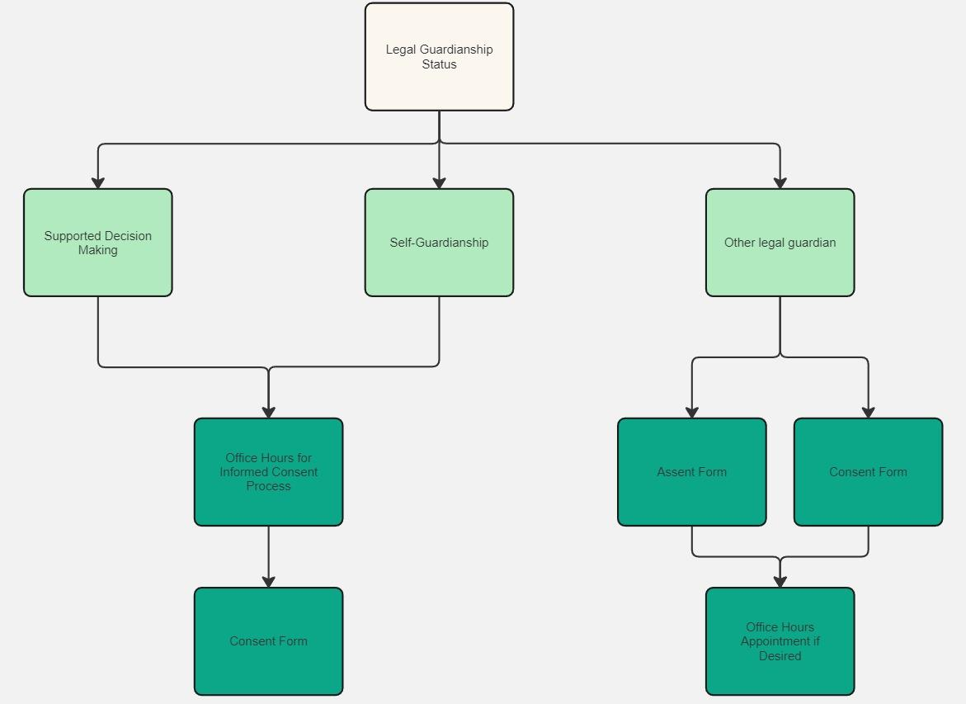

1. **STUDY PROCEDURES**

All data collected throughout the course of this research will be via REDcap. Participants will complete the eligibility form which the research team will review. Once deemed eligible, they will receive the consent form via REDcap’s email invitation process, meaning that their email and personal information will never leave REDcap. The participants will receive information as to when they may speak with the research team in an “open office hours” format to discuss the consent form, as well as how to contact the team to organize alternative times as needed. This will be included in the email sent to distribute the consent forms. Those who complete and return the consent form through REDcap will then receive an invitation to the survey through REDcap’s invitation process.

Survey responses will be collected through REDcap. The majority of the data will remain in REDcap unless de-identified for analysis in R Studio. There are some written short answer questions which will be deidentified and coded for analysis.

There is no remuneration for the study. Participants will not be receiving any interventions such as medical procedures or medication.

1. **Risks and Discomforts**

Participants will face minimal risk in this study. Privacy and confidentiality concerns are addressed by limited and private access to any identifying information, with storage in REDcap and a private password-protected Dropbox only. The research study should not pose significant psychosocial risks, but the researchers acknowledge that topics related to medical care may bring up difficult memories and emotional responses. All participants will have access to study staff and the Mass General Brigham IRB department should they have any concerns or complaints. Participants will be informed of the survey contents before agreeing to participate in the study as well as the opportunity to withdraw at any time. Participation will not affect the relationship or care they may receive at Mass General Hospital.

1. **Benefits**

There will be no direct benefit to participating individuals. There are potential benefits for society, with increased information as to the relationships between adults with Down Syndrome, their providers, and their caregivers. Increased understanding of the wishes and desires of the patient population can help strengthen these relationships and lead to more appropriate offerings of responsibility and autonomy for these individuals.

1. **Statistical Analysis**

Descriptive and comparative analysis will be performed on quantitative data. A Chi-Square test will be performed on basic demographic information to determine how representative the data will be to the larger population of adults with Down Syndrome. Descriptive analysis of Likert-scale responses will be done via ANOVA or t-test in R statistical software. Comparative analysis will look at differences between subgroups response patterns. Subgroups such as those answering with little to no aid from caregivers, those answering with more significant aid, and others, will be analyzed using pivot-tables, ANOVA, and/or t-test.

The statistical power of the survey will depend on the final recruitment numbers. Statistical support will be provided by IHP staff.

1. **Monitoring and Quality Assurance**

The principal investigator (PI), Gayun Chan-Smutko, and lead student researcher, Jackson Pearce, will be responsible for monitoring the data and integrity of the study. The study team will meet at least twice monthly to review data collection and adherence to the protocol. Adverse events are not expected, but should an anticipated problem arise, the PI will log the event, discuss the event with the Director of Student Research, and if needed, report the event in accordance with IRB policy.

1. **Data and Research Material Sharing**
   1. **Sending Data/Materials to Research Collaborators outside Mass General Brigham**

There will be no sharing of materials outside of Mass General Brigham.

* 1. **Receiving Data/Materials from Research Collaborators outside Mass General Brigham**

Within Mass General Brigham, data will only be shared between research staff and will only be accessed through secure storage of data in REDcap and a private password-protected Dropbox. All data will be de-identified and the materials that are shared will not be able to be linked with participants given that the only identifying information collected will be the participants email and consent/assent forms, which will only be used to distribute the survey and will remain stored in REDcap and/or Dropbox exclusively.

1. **Privacy and Confidentiality**

* Study procedures will be conducted in a private setting.
* Only data and/or specimens necessary for the conduct of the study will be collected.
* Data collected (paper and/or electronic) will be maintained in a secure location with appropriate protections such as password protection, encryption, physical security measures (locked files/areas)
* Specimens collected will be maintained in a secure location with appropriate protections (e.g. locked storage spaces, laboratory areas)
* Data and specimens will only be shared with individuals who are members of the IRB-approved research team or approved for sharing as described in this IRB protocol.
* Data and/or specimens requiring transportation from one location or electronic space to another will be transported only in a secure manner (e.g. encrypted files, password protection, using chain-of-custody procedures, etc.)
* All electronic communication with participants will comply with Mass General Brigham secure communication policies.
* Identifiers will be coded or removed as soon as feasible and access to files linking identifiers with coded data or specimens will be limited to the minimal necessary members of the research team required to conduct the research.
* All staff are trained on and will follow the Mass General Brigham policies and procedures for maintaining appropriate confidentiality of research data and specimens.
* The PI will ensure that all staff implement and follow any Research Information Service Office (RISO) requirements for this research.
* Additional privacy and/or confidentiality protections

**13. References**

[Crettenden, A., Wright, A., & Beilby, E. (2014). Supporting families: Outcomes of placement in voluntary out-of-home care for children and young people with disabilities and their families. *Children and Youth Services Review*, *39*, 57–64. https://doi.org/10.1016/j.childyouth.2014.01.021](https://www.zotero.org/google-docs/?C4W1kt)

[Kennedy, J., Wood, E. G., & Frieden, L. (2017). Disparities in Insurance Coverage, Health Services Use, and Access Following Implementation of the Affordable Care Act: A Comparison of Disabled and Nondisabled Working-Age Adults. *INQUIRY: The Journal of Health Care Organization, Provision, and Financing*, *54*, 0046958017734031. https://doi.org/10.1177/0046958017734031](https://www.zotero.org/google-docs/?C4W1kt)

[Kinnear, D., Morrison, J., Allan, L., Henderson, A., Smiley, E., & Cooper, S.-A. (2018). Prevalence of physical conditions and multimorbidity in a cohort of adults with intellectual disabilities with and without Down syndrome: Cross-sectional study. *BMJ Open*, *8*(2), e018292. https://doi.org/10.1136/bmjopen-2017-018292](https://www.zotero.org/google-docs/?C4W1kt)

[Lee, C. E., Urbano, R. C., Burke, M. M., & Hodapp, R. M. (2021). Who Lives Where and Why? Residential Changes Across Adulthood in Persons With Down Syndrome. *Journal of Policy and Practice in Intellectual Disabilities*, *18*(2), 151–161. https://doi.org/10.1111/jppi.12364](https://www.zotero.org/google-docs/?C4W1kt)

[Smith, A. J. B., Applebaum, J., Tanner, E. J., & Capone, G. T. (2020). Gynecologic Care in Women With Down Syndrome: Findings From a National Registry. *Obstetrics & Gynecology*, *136*(3), 518. https://doi.org/10.1097/AOG.0000000000003997](https://www.zotero.org/google-docs/?C4W1kt)

[Valentijn, P. P., Schepman, S. M., Opheij, W., & Bruijnzeels, M. A. (2013). *Understanding integrated care: A comprehensive conceptual framework based on the integrative functions of primary care* (1). *13*(1), Article 1. https://doi.org/10.5334/ijic.886](https://www.zotero.org/google-docs/?C4W1kt)

[van den Driessen Mareeuw, F. A., Coppus, A. M. W., Delnoij, D. M. J., & de Vries, E. (2020a). Quality of health care according to people with Down syndrome, their parents and support staff—A qualitative exploration. *Journal of Applied Research in Intellectual Disabilities*, *33*(3), 496–514. https://doi.org/10.1111/jar.12692](https://www.zotero.org/google-docs/?C4W1kt)

[Varshney, K., Iriowen, R., Morrell, K., Pillay, P., Fossi, A., & Stephens, M. M. (2022). Disparities and outcomes of patients living with Down Syndrome undergoing healthcare transitions from pediatric to adult care: A scoping review. *American Journal of Medical Genetics. Part a*, *188*(8), 2293–2302. https://doi.org/10.1002/ajmg.a.628](https://www.zotero.org/google-docs/?C4W1kt)